Start-up Screen

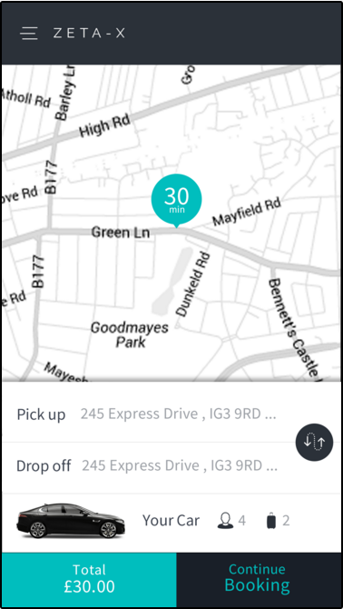

Process:

1. On load retrieve the current location and get the full address using reverse geocode. Use this address as pickup location. Make a web service call to the following endpoint to retrieve the nearest driver and display the driver’s traveltime on marker.

BaseURL+NearestDriver (POST)

Parameter: JSON Object

{

"Lat": 0.0,

"Lng": 0.0

}

Returns(JSON):

{

"code": 0,

"message": null,

"DriverID": 0,

"DriverNumber": null,

"FirstName": null,

"LastName": null,

"Distance": 0.0,

"TravelTime": 0,

"CurrentPosition": null

}

{

"Lat": 0.0,

"Lng": 0.0

}

Code: 1 success, 0 error

1. We need to always keep the marker in centre. As the customer drag the map repeat process 1.
2. Tapping on pickup and drop-off textboxes should take the customers to the screen below. Copy the address from the start-up screen. Frequently used locations should be retrieved from previous bookings. (We will provide the endpoint)

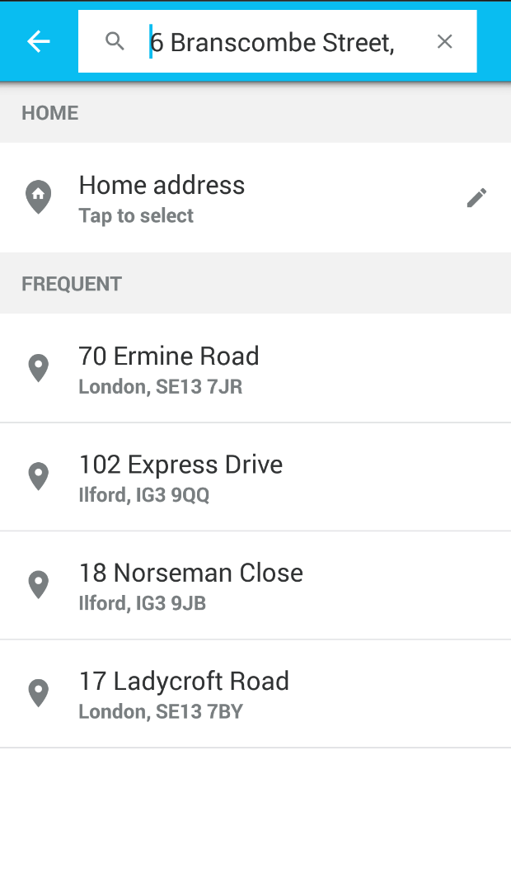

(This page has not been designed yet. Please follow the same styling as the previous page)

1. In addition to ‘Home Address’ and ‘Frequent’ make another section called ‘Nearest’. Make web service call to the following endpoint

BaseURL+ NearbyPlaces (GET)

Parameter: prefix //postcode returned in the previous step from reverse geocode

Returns(JSON):

{

"addresses": [],

"message": null,

"code": 0

}

{

"Outcode": null,

"Postcode": null,

"Fulladdress": null,

"Category": null,

"Icon_Path": null,

"Latitude": 0.0,

"Longitude": 0.0

}

Code: 1 success, 0 error

1. As the customers start typing you will need to make web service call to the following endpoint

BaseURL+SearchAddress (GET)

Parameter: prefix

Returns(JSON):

{

"addresses": [],

"message": null,

"code": 0

}

{

"Outcode": null,

"Postcode": null,

"Fulladdress": null,

"Category": null,

"Icon_Path": null,

"Latitude": 0.0,

"Longitude": 0.0

}

Code: 1 success, 0 error

1. Display full address in the list item and decide the icon based on category.

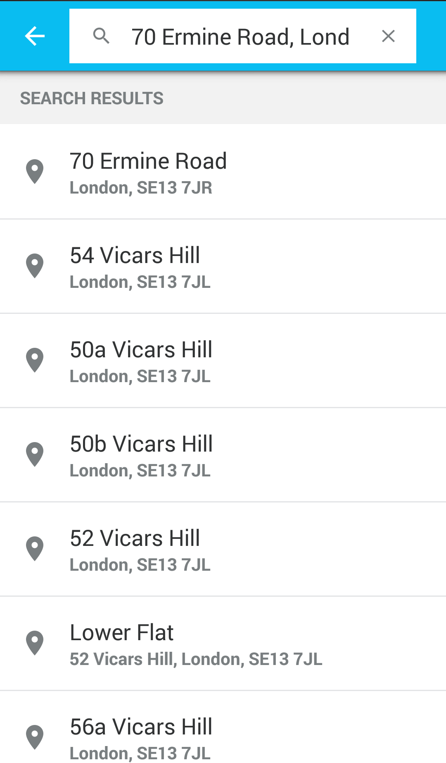

1. On selection take them back to the Home screen.



1. When you have both the pickup and dropoff addresses you will need to call another web service method at the following endpoint:

BaseURL+Quotation (POST)

Parameter: JSON Object

{

"viaLat": null,

"viaLong": null,

"custid": 0,

"pick": null,

"pickLat": 0.0,

"pickLong": 0.0,

"doffLat": 0.0,

"doffLong": 0.0,

"doff": null,

"via": null,

"bookingdate": "0001-01-01T00:00:00",

"paq": 0,

"bags": 0,

"note": null,

"returndate": null,

"rtnType": null,

"childseat": false,

"petfriendly": false,

"executive": false,

"pickpostcode": null,

"droppostcode": null,

"viapostcode": null

}

Pick: pickup address

pickLat: Pickup Address Latitude, which was returned in the previous step with address search result or current location latitude

pickLong: Pickup Address Longitude or current location logitude

doffLat: Dropoff Address Latitude

doffLong: Dropoff Address Longitude

doff: Dropoff Address

pickpostcode: Pickup Address Postcode which was returned in the previous step or current postcode from reverse geocode

droppostcode: Dropoff Address Postcode which was returned in the previous step

custid: Customer id is returned with the login request, send 0 if not logged in.

Returns (JSON):

{

"RoutePath": [],

"code": 0,

"message": null,

"vehTypeID": 0,

"rtn_routedistance": 0.0,

"routedistance": 0.0,

"rtn_traveltime": 0.0,

"traveltime": 0.0,

"vehType": null,

"totalfare": null,

"fare": null,

"returnfare": null,

"viaLat": 0.0,

"viaLong": 0.0,

"doLat": 0.0,

"doLong": 0.0,

"pkLat": 0.0,

"pkLong": 0.0,

"InServiceArea": false

}

{

"Lat": 0.0,

"Lng": 0.0

}

InServiceArea: if false then the company does not operate in that area (do not allow any further step)

Code: 1 success, 0 error

1. On ‘Continue’ button click take the customer to the summary/amendment page like below:

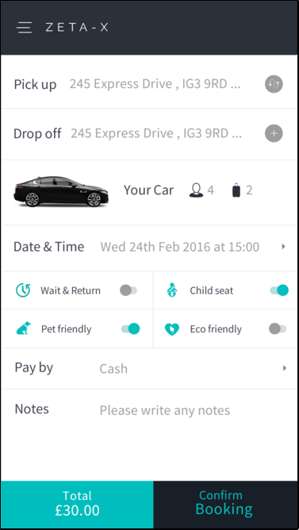

1. As the customer makes change you will need to call the web service method to get new quotation. (See BaseURL+Quotation (POST) above)
2. If the customer decides to go ahead and book, then we need to check if the customer is already logged in or not. If the customer is not logged in then we need to accept customer details like below:

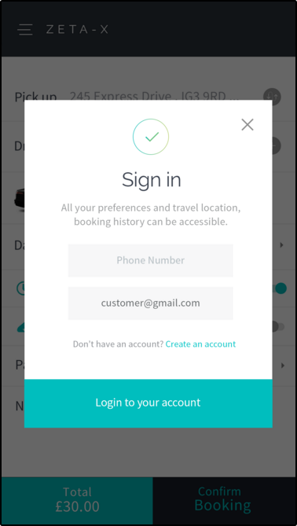

BaseURL+ SignIn (POST)

Parameter: JSON Object

{

"Mobile": null,

"Email": null,

"DeviceID": null

}

{

"CustID": 0,

"message": null,

"FormattedMobileNo": null,

"code": 0

}

Code: 1 success, 0 error

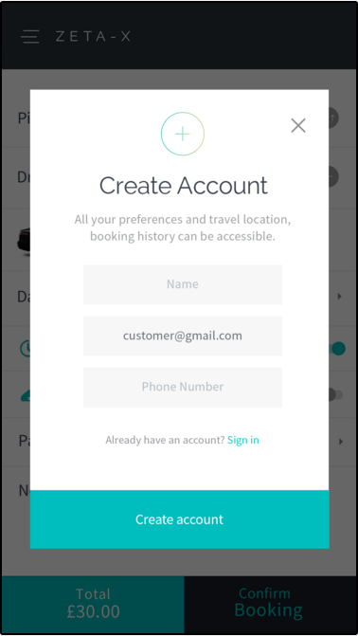

BaseURL+ SignUp (POST)

Parameter: JSON Object

{

"Name": null,

"Mobile": null,

"Email": null,

"DeviceID": null

}

{

"CustID": 0,

"message": null,

"FormattedMobileNo": null,

"code": 0

}

Code: 1 success, 0 error

1. Payment method

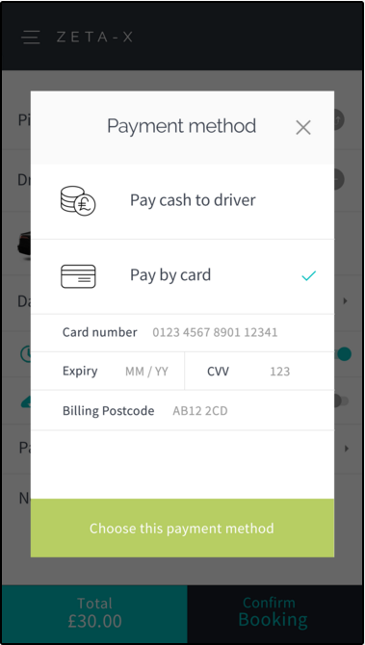

If pay by card is selected then you need to make web service call to the following endpoint first when confirming the booking. For cash payments go to step 13.

BaseURL + ElectronicPayment (POST)

Parameter(JSON):

{

"nonce": null,

"CustID": 0,

"Amount": 0.0

}

Returns:

{

"code": 0,

"message": null,

"Auth_Code": null

}

1. If the return code is 1 then make another call to the booking endpoint

BaseURL + SaveBooking (POST)

Parameter(JSON):

{

"Outcode": null,

"RtnOutcode": null,

"custid": 0,

"pick": null,

"doff": null,

"via": null,

"routedistance": 0.0,

"rtnroutedistance": null,

"vehType": null,

"vehTypeID": 0,

"travelTime": 0.0,

"rtntraveltime": null,

"totalfare": 0.0,

"returnfare": null,

"fare": 0.0,

"note": null,

"pkLat": 0.0,

"pkLong": 0.0,

"rjType": null,

"bookingdate": "0001-01-01T00:00:00",

"paq": 0,

"bags": 0,

"doLat": 0.0,

"doLong": 0.0,

"viaLat": null,

"viaLong": null,

"childseat": false,

"petfriendly": false,

"executive": false,

"returndate": null,

"InServiceArea": false,

}

Returns:

{

"code": 0,

"message": null,

"Auth_Code": null

}

If return code is 1 then take them to the screen below.

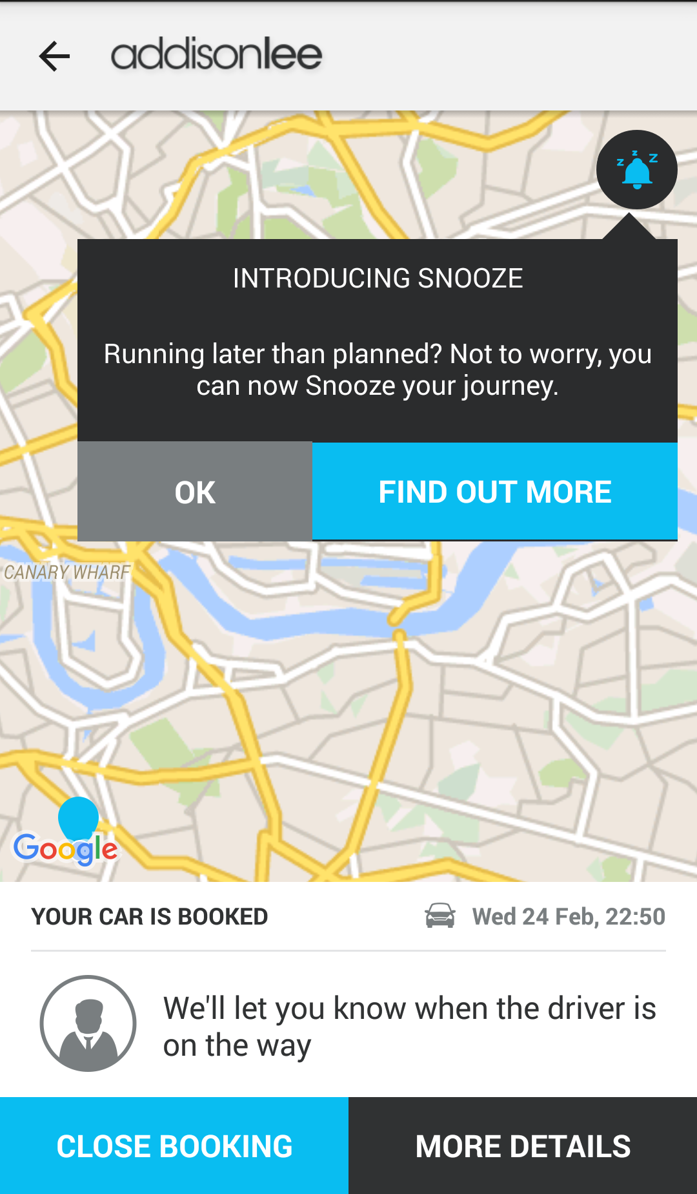

We will only have one button on the bottom of the screen ‘Booking Summary’ and we do not have snooze feature.

Booking Summary

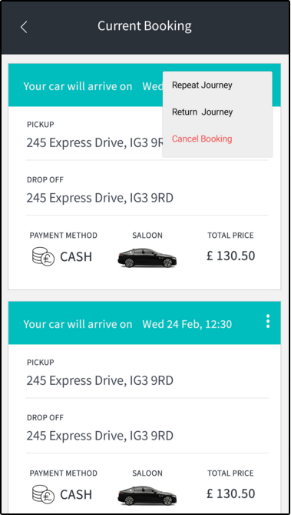

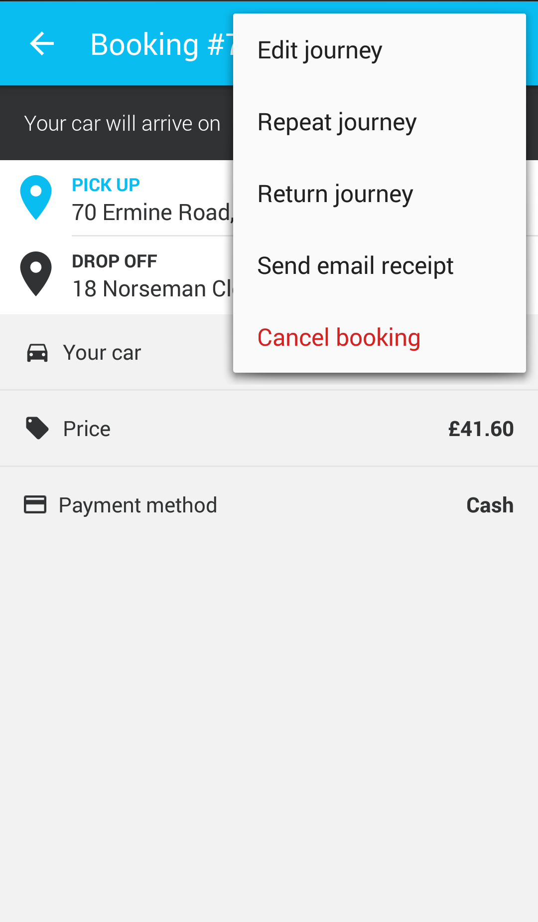

Please use this menu instead of the one on previous page.

Booking Summary ENDPOINT

BaseURL+ CurrentBookings (GET)

Parameter: JSON Object

{

"CustID": 0,

"DeviceID": null

}

{

"jlist": [],

"message": null,

"code": 0

}

{

"JobPartID": null,

"Status": null,

"Contact": null,

"PickupAddress": null,

"DropoffAddress": null,

"TotalFare": null,

"Notes": null,

"PickupDateTime": null,

"ViaLocations": null,

"FlightNumber": null,

"ExpFlightArrival": null,

"ChildSeat": null,

"Passengers": null,

"Suitcases": null,

"MeetAndGreet": null,

"PaymentMethod": null,

"JourneyType": null,

"VehicleType": null

}

Code: 1 success, 0 error

Main menu

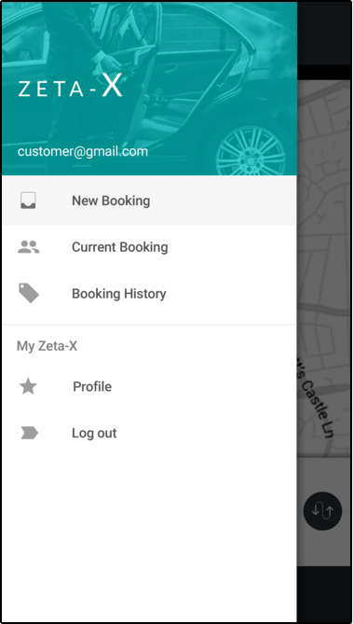

We will have a ‘login‘ option too. Until customer logs in ‘current booking’, ‘booking history’, ‘profile’ and ‘logout’ needs to be made invisible/disabled.

Booking History

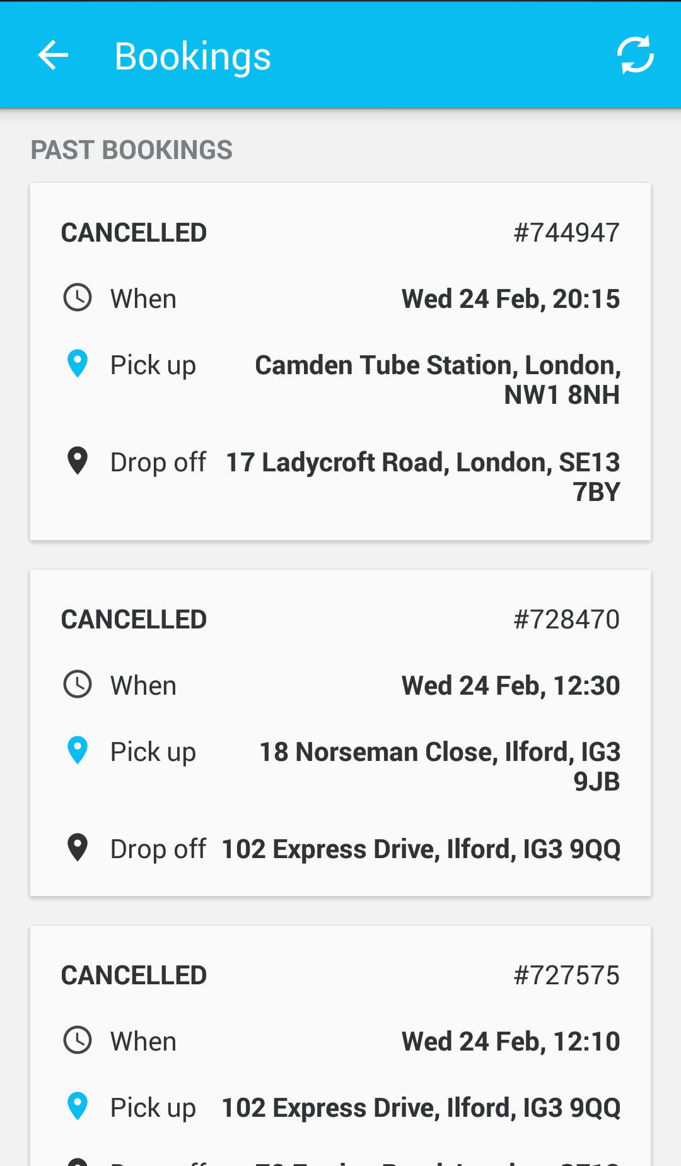

Booking History ENDPOINT

BaseURL+ JourneyHistory (GET)

Parameter: JSON Object

{

"Phone": null

}

{

"jlist": [],

"message": null,

"code": 0

}

{

"JobPartID": null,

"Status": null,

"Contact": null,

"PickupAddress": null,

"DropoffAddress": null,

"TotalFare": null,

"Notes": null,

"PickupDateTime": null,

"ViaLocations": null,

"FlightNumber": null,

"ExpFlightArrival": null,

"ChildSeat": null,

"Passengers": null,

"Suitcases": null,

"MeetAndGreet": null,

"PaymentMethod": null,

"JourneyType": null,

"VehicleType": null

}

Code: 1 success, 0 error

Car selection popup

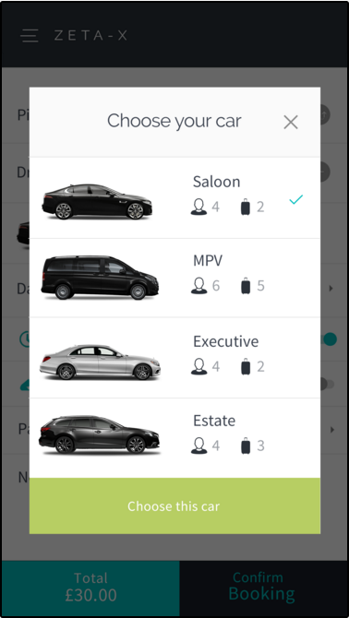

I will send some details on ‘vehicle tracking’ and ‘card payment’ once we have made some progress.